An enterprise architecture that connects what AI consumed with what it ultimately did.
Traditional application logs record deterministic operations. An enterprise AI system is different: prompts are assembled dynamically, retrieved evidence changes, model outputs vary, and autonomous agents can trigger irreversible actions. Consequently, an incident investigation cannot stop at “What API was called?” It must establish a defensible chain from the action back through the model context to the data that entered the AI supply chain.
The solution is a unified evidence architecture comprising an upstream cryptographic provenance ledger and a downstream AI black-box recorder.

Upstream: The Cryptographic Ledger Blueprint
Provenance must be captured before a document becomes an embedding, fine-tuning example, or RAG context. The ingestion gateway first preserves the original bytes, then creates a deterministic, normalized representation, and finally classifies the asset for sensitivity, ownership, geography, licensing, consent, permitted purpose, and retention.
It then generates three linked identities:
- Source hash: The fingerprint of the original asset.
- Content hash: The fingerprint of each normalized chunk.
- Derivation ID: A hash binding the source, transformation code, configuration, chunk position, and resulting content.
Each manifest is signed using an HSM- or KMS-protected ingestion identity and appended as a leaf in an append-only Merkle log. Periodically signed tree roots make deletions, substitutions, and rewritten history detectable through inclusion and consistency proofs—the same cryptographic principle used by certificate-transparency systems. RFC 9162 describes how Merkle trees provide efficiently verifiable append-only logs.[https://datatracker.ietf.org/doc/rfc9162/]
The ledger should not contain raw documents or sensitive prompts. Those belong in an encrypted evidence vault protected by write-once-read-many retention and legal-hold controls. The ledger stores hashes, signatures, policy decisions, and encrypted evidence references. Only periodic Merkle roots need to be anchored outside the primary security boundary. This separation reduces privacy exposure while preserving integrity.
For RAG, every vector record carries its chunk_hashprovenance receipt, embedding-model version, and index snapshot. For fine-tuning, a signed training manifest links the resulting model artifact to the complete dataset root, base-model identifier, pipeline version, and approval record. Provenance schemas can align with the W3C’s Entity–Activity–Agent model and dataset/job/run concepts from OpenLineage.[https://openlineage.io/docs/spec/object-model/]
Content addressing alone is not immutability. It identifies changed content; it does not guarantee retention, lawful use, or protection against deletion. Enterprise-grade immutability is therefore a composite control: hashing, digital signatures, append-only transparency, WORM retention, independent monitoring and separation of duties.

End-to-End Architecture:

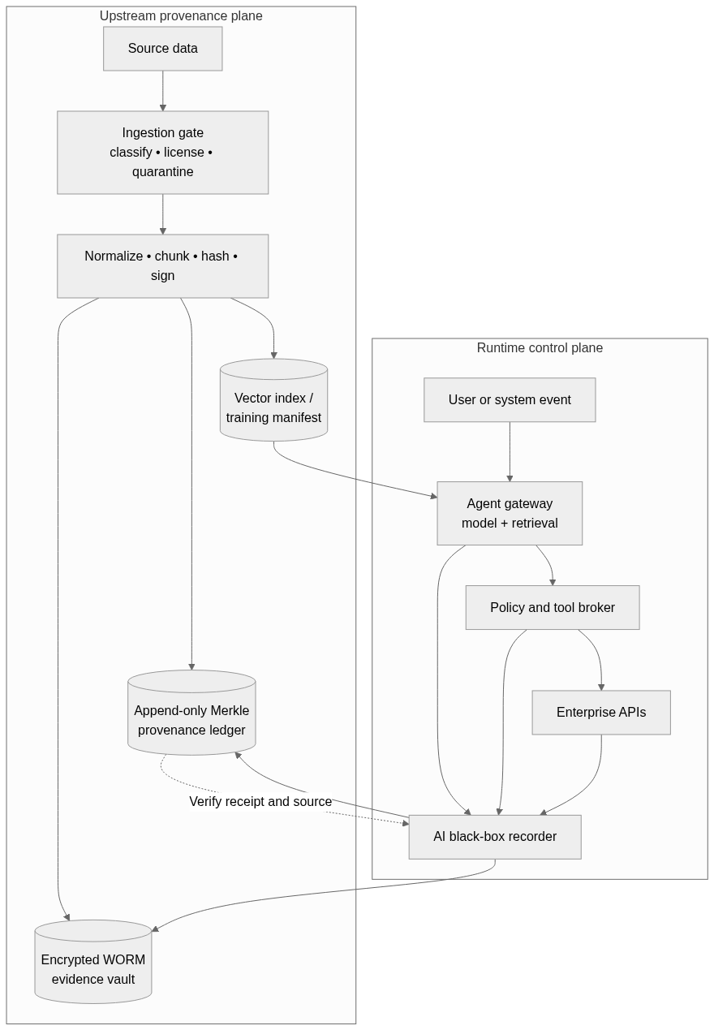

Downstream: The AI Black-Box Recorder
The recorder must operate at an unavoidable execution chokepoint. Agents receive no direct network credentials; every database query, email, payment, infrastructure change or external API request passes through a policy-enforcing tool broker.
For each transaction, the recorder captures the authenticated principal and tenant; model and agent versions; encrypted prompt envelope; prompt-template and tool-schema hashes; generation parameters; retrieved vector IDs, rankings and provenance receipts; policy version and verdict; human approval, where required; proposed tool payload; destination; external request ID; response status; and output hash.
Recording follows a two-phase protocol. An INTENT event is durably committed before the side effect occurs. The resulting RESULT event is then linked to it using the previous event hash. For high-impact actions, failure to obtain a signed pre-execution receipt causes the broker to fail closed. Lower-risk, read-only interactions can use a signed local buffer and asynchronous ledger anchoring to control latency.
INGEST(source):
raw_hash = HASH(source.bytes)
chunks = deterministic_transform(source)
for chunk in chunks:
manifest = {
raw_hash, HASH(chunk), HASH(transform_code + config),
origin, rights, classification, retention, ingestion_run
}
evidence_ref = WORM.put(ENCRYPT(chunk))
receipt = LEDGER.append(SIGN(manifest, evidence_ref))
VECTOR_INDEX.upsert(embed(chunk), HASH(chunk), receipt)

EXECUTE(tool_candidate):
context = retrieve_with_ids_scores_and_receipts()
verdict = POLICY.evaluate(tool_candidate, context)

intent = SIGNED_EVENT(
"INTENT", trace_id, model_version, prompt_hash,
context, tool_candidate, verdict, approval_id
)

if risk_is_high and not RECORDER.precommit(intent):
DENY_ACTION()

result = TOOL_BROKER.call(
tool_candidate, idempotency_key=trace_id
)

RECORDER.append(
SIGNED_EVENT("RESULT", HASH(result), previous=HASH(intent))
)
This design deliberately avoids treating hidden chain-of-thought as authoritative evidence. Some models do not expose raw reasoning, and research shows that generated reasoning can rationalize an answer without faithfully representing its cause. Chain-of-thought faithfulness research [https://arxiv.org/abs/2305.04388] supports treating explanations as model-generated assertions—not forensic ground truth. A recorder should instead preserve observable decision evidence: the exact instructions, accessible context, model configuration, policy decisions, tool request, and resulting side effect. Optional structured reason codes may assist reviewers but must be labelled as non-authoritative.

From Incident to Root Cause
Suppose an agent transmits customer data to an unauthorized endpoint. The investigator starts with the external request ID and retrieves its RESULT and preceding INTENT. The trace reveals the prompt version, authorization verdict, and RAG context. Each retrieved vector ID resolves to a signed ledger receipt, which identifies the originating document, transformation, licensing state and ingestion approval.
The enterprise can then quarantine the compromised source, invalidate every derived vector or fine-tuned artifact, and identify all historical transactions exposed to it. This converts lineage from passive documentation into an active containment control.
The evidence boundary must nevertheless remain explicit. The system can prove what information was supplied to the model and what action followed; it cannot mathematically prove that one fragment caused the neural decision. Exact attribution to base-model pre-training weights remains an open research problem.
This architecture supports the direction of controls in the NIST Generative AI Profile [https://nvlpubs.nist.gov/nistpubs/ai/NIST.AI.600-1.pdf], which emphasizes data provenance, retention and incident records, and the EU AI Act’s record-keeping expectations for high-risk AI systems. Its strategic value is not “reading the model’s mind.” It is creating a verifiable chain of custody across data, context, policy and execution—reducing investigation time, limiting legal exposure and giving risk teams evidence that can withstand scrutiny.

